DSA 210 Project Report
Forecasting Future Sales Using Company Transaction Data
Name: Ömer Erhal
Student ID: 31032

1. Motivation
The main motivation of this project is to understand whether future sales performance can be predicted using historical company transaction data and to identify which operational and economic factors meaningfully influence sales behavior. As the company operates in the iron and steel industry, accurate sales forecasting is crucial for inventory planning, cost control, and strategic decision-making. This project provides an opportunity to apply the full data science pipeline learned in DSA 210, including data cleaning, exploratory data analysis, hypothesis testing, and machine learning, on a real-world industrial dataset.

2. Data Source
The dataset consists of internal company records and external macroeconomic data:
- Sales transaction records: daily sales quantities and prices
- Purchase transaction records: daily stock intake quantities
- External data: daily USD/TRY exchange rate (2024–2025)
Due to the commercially sensitive nature of the data, raw datasets cannot be shared publicly. Therefore, only aggregated results and limited visualizations are included in this report.

3. Data Cleaning and Preparation
The following preprocessing steps were applied:
- Converted all date columns to datetime format
- Standardized numeric columns (decimal separator corrections)
- Removed invalid and zero-valued observations
- Forward-filled missing price values
- Aggregated sales and purchases into daily and monthly tables
- Corrected extreme unit inconsistencies (e.g., 114000 → 114 tons)
- Merged sales data with USD/TRY exchange rate data

4. Exploratory Data Analysis (EDA)
Exploratory analysis was conducted using boxplots and scatter plots.
Key observations:
- Sales quantities exhibit a strongly right-skewed distribution
- Sales prices are concentrated in a narrow range with a few extreme outliers.
- Scatter plots show no visible relationship between sales price and sales quantity.
- Purchases do not show a clear visual relationship with daily sales.
- 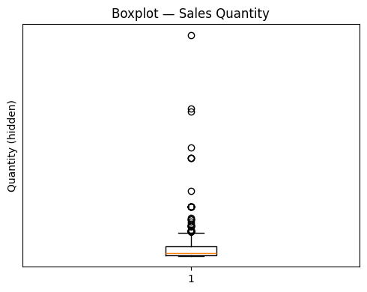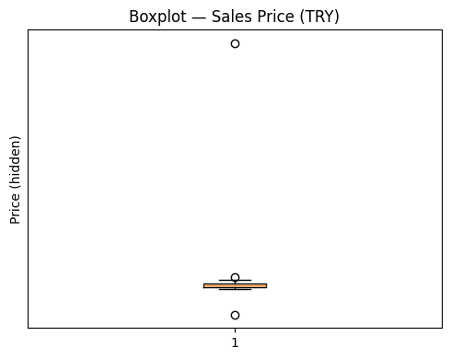
- 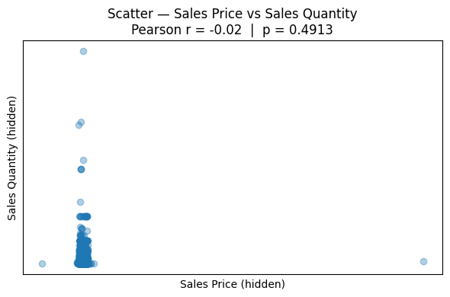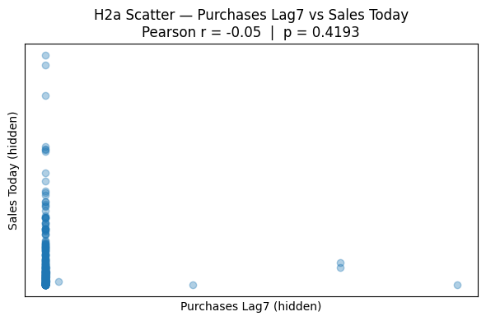
- 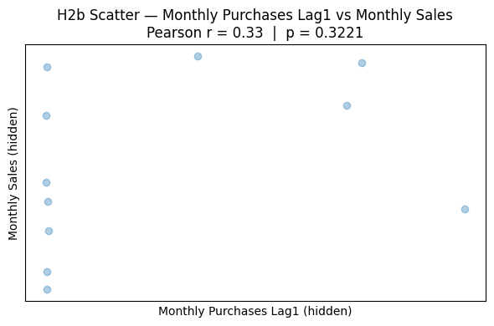

5. Hypothesis Testing
Hypothesis tests were performed using Pearson correlation and linear regression (r and p-values).
Hypothesis 1: Past Sales → Future Sales
Lag | Correlation (r) | p-value | Interpretation
7-day | -0.1026 | 0.1093 | Not significant
21-day | -0.0231 | 0.7266 | Not significant
30-day | 0.0475 | 0.4809 | Not significant
Conclusion:
Daily lagged sales quantities do not show statistically significant linear relationships with future sales.

Hypothesis 2: Purchases → Future Sales
- Daily purchases (lag = 7 days):
r = -0.0515, p = 0.4193 → not significant
- Monthly purchases → next month sales:
r = 0.3296, p = 0.3223 → not significant
Conclusion:
Purchase quantities do not have a statistically significant linear effect on future sales.

Hypothesis 3: Price → Sales Quantity
- r = -0.0180
- p = 0.4913
Conclusion:
Sales prices do not significantly affect sales quantity; demand appears price-inelastic within the observed range.

Hypothesis 4: USD/TRY → Sales Performance
- USD/TRY → Sales Price:
r = 0.3000, p = 0.000001 (significant)
- USD/TRY → Sales Quantity:
r = -0.0746, p = 0.2354 (not significant)
Conclusion:
Exchange rate changes strongly affect sales prices but do not directly affect sales volume.

6. Summary of Statistical Findings
- No significant linear relationship between daily past sales and future sales
- Purchase quantities do not significantly affect sales
- Sales prices do not influence quantity sold
- USD/TRY strongly influences prices but not quantities
- Weak monthly seasonality exists, but not strong enough for linear significance

7. Machine Learning Methods
To complement statistical analysis, supervised machine learning methods covered in the course were applied:
- Decision Tree Regression
- k-Nearest Neighbors (k-NN) Regression
- Random Forest Regression
Features used:
- Lagged sales quantities (1, 7, 30 days)
- Daily average sales price
- Daily purchase quantity
Models were evaluated using TimeSeriesSplit (5-fold cross-validation). Performance was measured using Average Prediction Error, defined as the average absolute difference between predicted and actual values.

8. Machine Learning Results
Horizon = 1 Day
Model | Average Prediction Error
Lag-1 Baseline | 1032.12
Lag-30 Baseline | 1050.11
Decision Tree | 853.25
k-NN | 843.78
Random Forest | 767.25
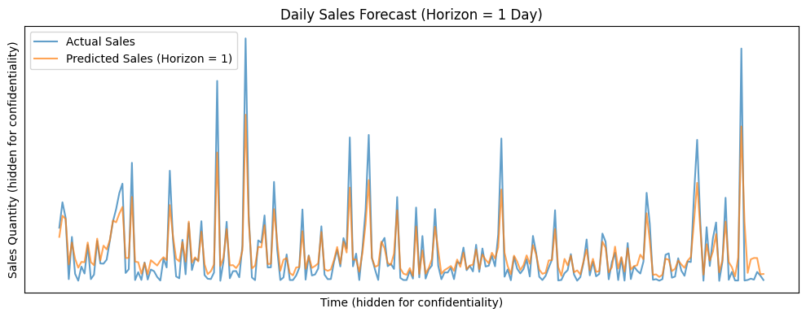
Horizon = 30 Days
Model | Average Prediction Error
Lag-1 Baseline | 1021.97
Lag-30 Baseline | 976.12
Decision Tree | 878.78
k-NN | 730.20
Random Forest | 792.90
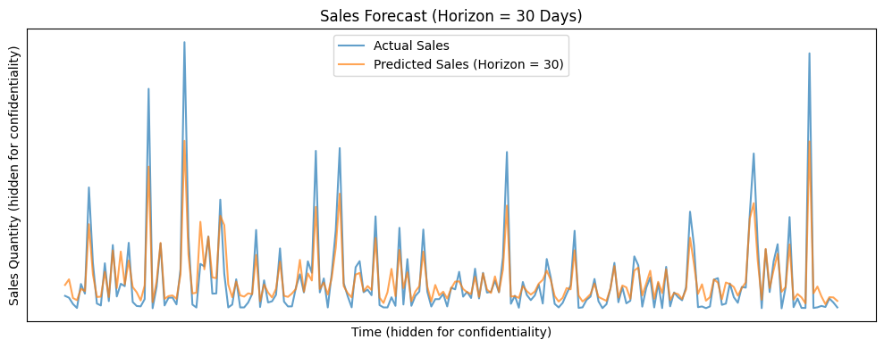
9. Discussion
Although individual variables do not exhibit strong linear relationships with future sales, combining multiple lagged features in non-linear machine learning models significantly improves forecasting accuracy. Random Forest reduces short-term prediction error by approximately 26% compared to the Lag-1 baseline, while k-NN achieves the best performance for 30-day forecasts with a reduction of approximately 25% compared to the Lag-30 baseline.

10. Conclusion
The purpose of this project was to evaluate whether future sales can be predicted using historical company transaction data and to understand which factors meaningfully influence sales behavior. The results indicate that while daily sales dynamics are highly volatile and not well explained by linear models, meaningful predictive patterns emerge through non-linear machine learning methods. Exchange rate fluctuations primarily affect prices rather than quantities, and inventory planning plays a more important role at monthly horizons. Overall, this project demonstrates how combining statistical analysis with machine learning can support better demand forecasting and operational decision-making in real-world industrial settings.

IMPORTANT NOTE (Data Confidentiality)
Due to the commercially sensitive nature of the company’s transaction data, the number and level of detail of visualizations were intentionally limited. Axis values in several plots were hidden to preserve confidentiality while still demonstrating model behavior and analytical insights. (Other graphs can be view on the GitHub Code page if wanted).

